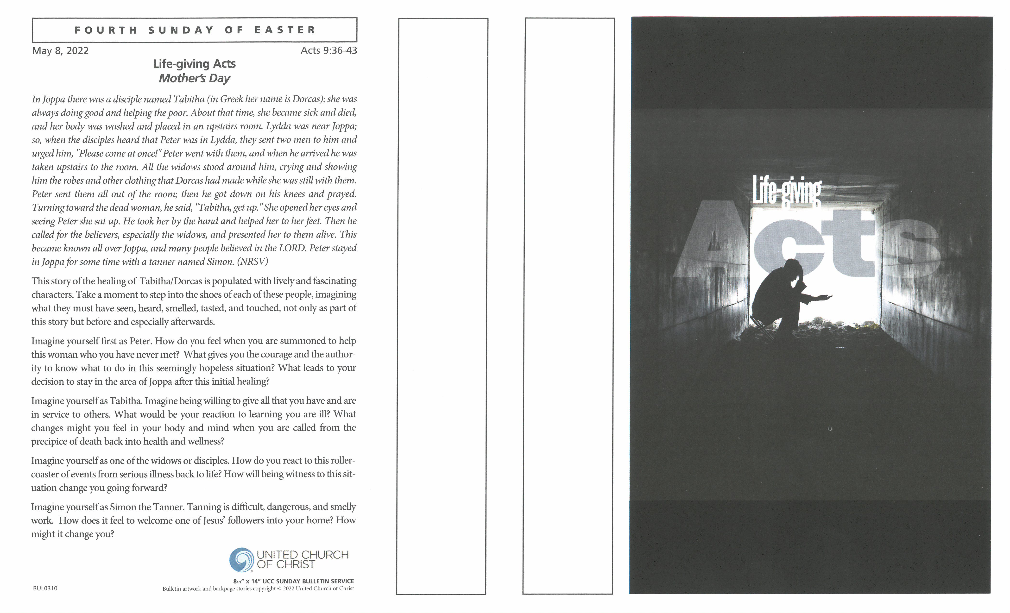

Thank you for worshiping with us this morning. We extend a special welcome to our guests.

F

or Children: We have trained nursery staff (paid nursery attendant as well as adult volunteers) for ages 0-4. The nursery is located on the first floor outside of the Community Room. (Accessible by the stairs from the Church Street Entrance or via the elevator). Children ages 5 and above are invited to stay and worship with their families. Children’s programs, books, and crayons are located in the rear of the sanctuary near the welcome table.

H

ymn selections can be found in the black hymnals in the pew racks or printed in the bulletin. If you are visiting and did not stop at the welcome desk in the downstairs lobby please stop by after the service they would love to meet you or, please feel free to reach out to someone sitting near you and ask them questions about the service or church. Many of our visitors ask us about the time of offering. This is a time in our service when we respond to God’s gifts of love by offering the gifts of our lives. For many of us, this is when we make a financial gift towards the ministries and programs of our church. We also use this time to ask God how we might use the gifts of our hands and hearts in sharing God’s love. If you are visiting, there is no obligation to give a financial gift. We are just glad you are worshiping with us. At this time, we are taking offering at the end of the service. Plates for offering will be placed at the doors as you exit the sanctuary. Thank you.

W

e ask that you please silence your cell phones during our worship service. We also ask that you refrain from applause after our choirs sing and allow the music to resonate in the quiet of the sanctuary and in your hearts. Our musicians are playing and singing for the glory of God. They know you appreciate their efforts and their gift.

Rest rooms (equipped with changing stations) are located on the first floor of the church building and outside the Community Room and the Nursery.

T

here is much information about the church in this bulletin and our website: www.erucc.org.



Donate online by scanning this code:

*or* download the **GivePlus Church** application and

make your donation via the app. Thank you.

**Ministers - All the People of Evangelical Reformed Church**

Rev. Dr. Barbara Kershner Daniel, Senior Pastor (bkdaniel@erucc.org)

Rev. Fred Wenner, Pastor Emeritus (burschenherrlichkeit@gmail.com)

Kim Sexton, Associate for Children’s Ministry (ksexton@erucc.org)

Alison E. Shafer, Music Director ● Tricia Coffey, Head Chimer & Children & Youth Choir Director

Sherry Murray, Nursery ● Jaci Clayton, Facilities Mgr.

Tyler L. York, Office Administrator (tyork@erucc.org) ● Jenna Duranko, Social Media Coordinator

***15 West Church Street, Frederick, MD 21701* ⚫  *301-662-2762* ⚫  *www.erucc.org***

**EVANGELICAL REFORMED CHURCH**

United Church of Christ

- An Open and Affirming Congregation -

May 8, 2022 Fourth Sunday of Easter 10:30 am

The numbered hymns are from The New Century Hymnal

*All who are able may stand

**Chimes Concert** at 10:00 am from Trinity Chapel’s steeple

**Greetings and Announcements**

**\*Choral Call to Worship** *Joy Together* -- C Townley, arr. Butler-Moore

**Joy together and worship the name. Joy together in Jesus.**

**Joy together and worship the name. Joy together in Jesus.**

Refrain:

**Celebrate joy and worship the name. Joy together in Jesus.**

**Celebrate joy and worship the name. Joy together in Jesus.**

**Praise together and worship the name. Praise together in Jesus.**

**Praise together and worship the name. Praise together in Jesus.**

**Refrain**

**Live together and worship the name. Live together in Jesus.**

**Live together and worship the name. Live together in Jesus.**

**Refrain**

**\*****Call to Worship**

Come into the presence of the One who is gracious to us, blesses us, and whose face shines upon us.

**We gather at the river of the water of life.**

Come into this sacred space and join your voices with peoples of all nations in praise of the One who shows us the way of peace.

**We gather at the river of the water of life.**

Come into the presence of the One were night is as day and fear is driven out by God’s love.

**We gather at the river of the water of life.**

Come and listen to for the Spirit’s voice, calling us to live with courage and faithfulness to the vision of God’s justice.

**We gather at the river of the water of life, trusting the One who is our light and our hope.**

**\*Opening Prayer**

**Holy One, even when we have felt most alone, your spirit is present to us, your promise is fulfilled. Even when we have felt like we have little of value to offer, your spirit shows us the fruit of love is abundant and there for the healing of the nations. Even in the midst of loud voices encouraging hatred, fear, and selfish ambition, your spirit quietly beckons us to journey forth to the place of love’s calling. Help us in this time of worship to trust the voice of your spirit that we may live as your people. Amen.**

**\*****Opening Hymn***Rain Down* -- J. Cortez

Refrain:

**Rain down, rain down, rain down your love on your people.**

**Rain down, rain down, rain down your love, God of life.**

**\*Call to Confession**

**\*Prayer of Confession**

**Loving God, we reflect upon those times when we have not acknowledged**

**your presence with us: in nature, in city streets, in daily living,**

**in challenging times, in wonderful times, in all the in-between times,**

**in times of need, when we feel hounded by enemies, when we are cared for**

**by “shepherds,” in the faces of the many people we encounter each day.**

**Forgive us, God.**

**Inspire us to worship and celebrate your presence in every moment. Amen.**

**Assurance of Pardon**

Whether we are lost or confused, wandering or waiting, God’s love is steadfast. Faithless or doubting, disobedient or disowning, God is present to us. Weary or distracted, tired or defeated, we are held in God’s sustaining, nurturing love.

**Sacrament of Baptism** page 31

**Thought for the Day**

**The Lord’s Prayer**

**Our Father, who art in heaven**

**hallowed be thy name.**

**Thy kingdom come. Thy will be done**

**on earth as it is in heaven. Give us this day our daily bread.**

**And forgive us our debts, as we forgive our debtors.**

**And lead us not into temptation, but deliver us from evil.**

**For thine is the kingdom, and the power, and the glory, for ever. Amen.**

**\*Hymn** *God Made from One Blood* tune – MÜLLER

**God made form one blood, all the families of earth,**

**the circles of nurture that raise us from birth,**

**Companions who join us to work through each stage**

**of childhood and youth and adulthood and age.**

**We turn to you, God, with our thanks and our tears**

**for all of the families we’ve known through the years,**

**The intimate networks on whom we depend**

**of parents and partners and children and friends.**

**Through families we’ve tasted the value of trust**

**and felt what it means to be loving and just,**

**Yet families have also betrayed their best goals,**

**mistreating their members and bruising their souls.**

**Help families in all of their various forms**

**to face with integrity struggles and storms;**

**Grant peace to our homes that will nurture the bud**

**of peace for the families you made from one blood.**

**The Scripture**

Acts 9: 36-43 NT Page 128

John 10: 22-30 NT Page 104

Reader: The Word of God for the people of God.

**All: Thanks be to God.**

**Meditation**

**Morning Prayers**

**– AFFIRMATION OF MINISTRY –**

**Greetings and Introduction**

Grace, mercy, and peace to you from Jesus Christ, the head of the church in heaven and on earth.

**To God be glory in the church and in Christ Jesus to all generations, for ever and ever. Amen.**

Affirmation of ministry is the act whereby a local church of the United Church of Christ recognizes the diverse gifts of its members and celebrates the particular ministry of each person in the life of the church or in various settings in the life of the world. There are different kinds of spiritual gifts, but the same Spirit gives them.

**There are different ways of serving, but the same God is served.**

There are different abilities to perform service, but the same God gives ability to each of us for our particular service.

**The Spirit’s presence is shown in some way in each person for the good of all.**

Christ is like a single body, which has many parts.

**It is still one body even though it is made up of different parts.**

If one part of the body suffers, all the other parts suffer with it; if one part is praised, all the other parts share its happiness.

**All of us are Christ’s body, and each one is a part of it.**

**Presentation**

These people have been called by God, in accordance with the faith and order of this church, to serve among us. They have accepted their call and are before us in witness to their willingness to serve.

**Covenant**

Sisters and brothers in Christ, it is an honor to be entrusted with responsibility for particular service in the ministry of the church, whether gathered or scattered.

Having prayerfully considered the duties and responsibilities of your ministry, are you prepared to serve with the help of God in Christ’s name and for the glory of God?

*Response:* I am

Do you promise to exercise your ministry diligently and faithfully, showing forth the love of Christ?

*Response:* I do, relying on God’s grace.

Members of this household of faith, you have heard the promises of our brothers and sisters in Christ who have answered God’s call to service. Let us affirm our intention to live in covenant with them. Will those who are able rise and witness to the commitment we now make?

**We gather in celebration of the joy that is ours to be partners with you in the service of Jesus Christ. We promise to love you, honor your leadership, and assist you that together we may be a faithful church of Jesus Christ.**

**Declaration**

In the name of Jesus Christ, and on behalf of the people of Evangelical Reformed United Church of Christ, I rejoice to announce you are installed in your respective positions. In accordance with the faith and order of this church, I extend to you the hand of Christian love.

**Thanks be to God.**

**Offering of Tithes, Gifts and Lives to Christ’s Service**

**Offertory** *Love Will Be Our Home* -- S. Patti

Spirit

**\*Prayer of Dedication**

**Gracious and generous God, all of us rely on the care, support, and example of others to teach us about the ways your transforming spirit is at work in our world. May these offerings reflect our desire and our commitment to keep your word, the promise of renewing love for all the earth.**

**\*Closing Hymn** *Called as Partners in Christ’s Service* #495

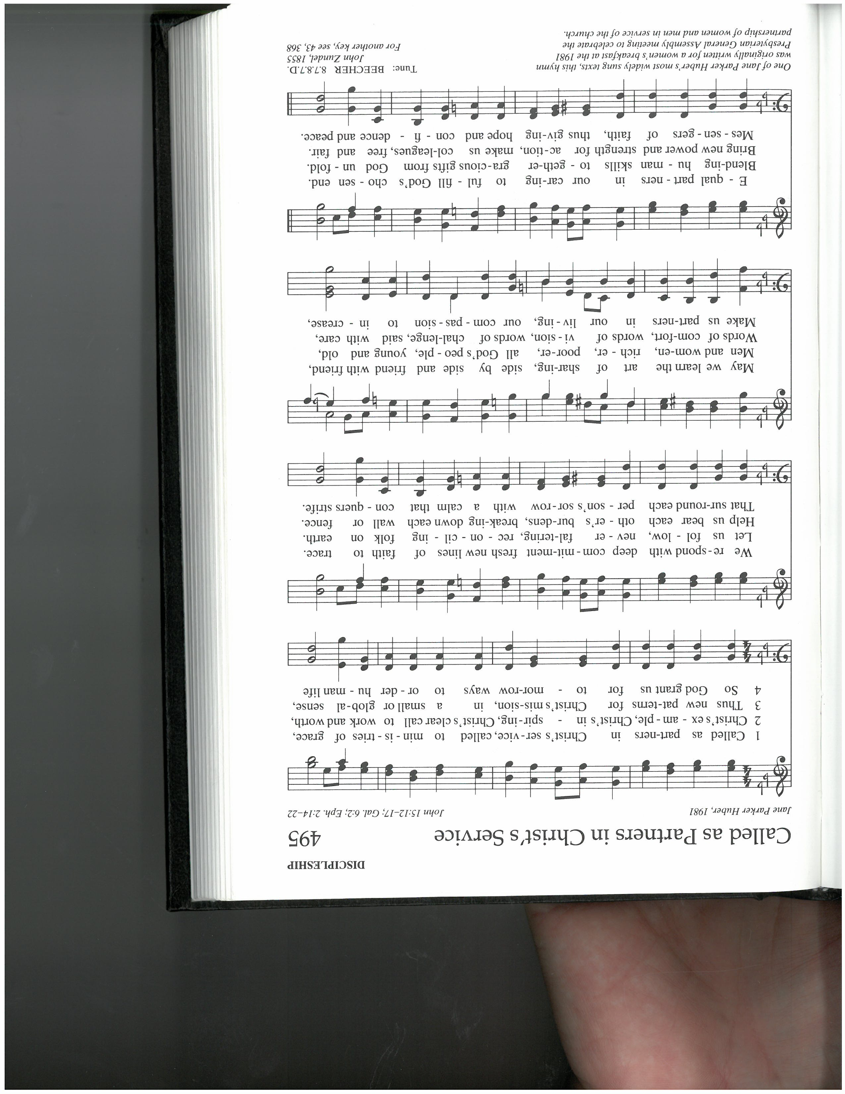

**\*Benediction**

Go forth knowing the spirit entrusts us with a vision of God’s love for all peoples.

**We go prepared to hear those whose voices are often ignored.**

May God’s blessings for the nations and the earth continue to increase through your faithfulness.

**We have been renewed by the waters of life. Our hearts are open. We will share the peace we have received.**

Go forth eager to listen, knowing the power that is at work in you.

**We praise the God of justice, who offers healing to all the nations. We join the chorus of all those who live believing a new day is coming when the light of God’s love will be known by all.**

**\*Choral Benediction** *An Old Irish Blessing* -- T. Jennings

**May the road rise up to meet you,**

**May the wind be always at your back,**

**May the sun shine warm upon your face,**

**And the rain fall soft upon your fields,**

**and until we meet again, until we meet again**

**May God hold you in the hollow of his hand,**

**until we meet again.**

**Postlude** *(please be seated)*

**Baptism:** Today we welcome Aoifé James Menchey Lynch through the Sacrament of Baptism. Aoifé is the daughter of Sando Menchey Bernstein Lynch and Oliver John Penn Lynch and was born on February 27, 2022.

**The flowers on the altar** this morning are dedicated to the praise and glory of God.

**The yellow rose bud** is presented by Peter Brehm and Jack Day.

**Attendance Last Sunday:** 13 at 8:30 am, 113 at 10:30 am, and 86 online.

**Watch worship live every Sunday at 10:30 am**

https://sundaystreams.com/go/ERUCC

Want to listen to the sermon again?

Visit our YouTube channel: **bit.ly/erucc­*_*youtube**

**Today: May 8, 2022 Next Week: May 15, 2022**

Liturgist: Peg Stahler Marc Kline

Deacons: Chuck Baldree, Matt Pomeroy Joe Adkins, Matt Davis

Elder: Marc Klein Gerry Blessing

Greeters: Cathie Duncan, Jo Ann Fritz, Rachel and Tom Ford, Sue Pinner Linda Coyle

Welcome: Jeanellen Kallevang Holly Davis

Audio/Visual: Jeff Schaeberle, Larry Martin Rodney Martin, Jeff Schaeberle,

Jeff Baker, Jack Day Tadd Clarkson

Fellowship: Marj Berkheimer, Peter Brehm

Starr Schaeberle, Keith Stickley Will and Cathie Duncan

Chimers: *Saturday:* Dick Williams Nancy Doll

*Sunday:* Kelly Esslinger Robin and David Cooney

**FELLOWSHIP**

Please join us for fellowship in the Community Room after worship to chat with friends, welcome our visitors, and enjoy a time of refreshment.

The Community Room, located on the 1st floor, is accessible by stairs or elevator.

**ANNOUNCEMENTS**

**Worship Next Week: Fifth Sunday of Easter**

A person may say, “The road to hell is paved with good intentions.” The wiser one says simply, “The road to hell is paved.” Seductively smooth, wide and straight it runs, and by comparison the Holy Way can at times seem like an old cow path meandering through the woods riddled with stones and hanging branches. Yet as followers of Christ this shouldn’t come as a surprise, and the glory of the destination, our joy in the company we keep, and our faith in the One who calls us can make it feel like we’re walking on water. As we read from Psalm 148, Revelation 21:10, 22-22:5, and John 13:31-35 we’ll explore what it means to “Go With the Flow” for God.

Rev. Michelle Beadle will be preaching this morning. The Senior Choir will be singing.

**Hospital and Prayer List –** Your pastor wants to be available when members of ERUCC are in the hospital. Please let us know so that we can visit with you and your family and provide support. We always ask permission before adding a name to be included in the prayer list or in the verbal announcements on a Sunday morning. There are many for whom we pray and visit whose names are not listed in the bulletin by their request.

**Prayer List -** Please remember the following people in your prayers: Tamara Tamas, Ken Hoffman, Patti Patterson, Katharine Alley, Barbara Lee Crutchley (sister of Milt Crutchley), Marcy Channell (daughter of JoAnn Fritz), Mack Johnson, David Howard, Paige Coffey, Al Peden, Jane Doll, Michael Rhoads (son of Barbara Rhoads), Westin (great nephew of Sandy Gray & Danielle Carbone, Peggy Githerman, Jeannette Johnson, Emogene Wyand, Fran Wenner, Neremiah Castillo (niece of Andrew Beadle) Bonnie Devilbiss, Maria Csiba (mother of Tamara Tamas), Betsy Fisher, James “Jimmy” Sutphin (friend of Dan Smith), The McCarty family, Nikki Keller, Tina Prescott (daughter in law of Barbara and Bill Prescott), Mary Remsberg, Heleen (sister of Karin Mens), Kathy Blue Shores (friend of Jean Fish and Barb Biser), Gretchen Manuel (niece of Audrey Rayfield), Ann and Cal Theiss (parents of Katharine Alley), Debra Reedy (friend of Jean Fish and Barb Biser).

**STAY INFORMED**

Read our Trinity Chimes monthly newsletter for more information about ERUCC activities, opportunities, and updates. You can find the Trinity Chimes in the back of the sanctuary and online at **bit.ly/May22Chimes**.

If you have an announcement for the bulletin, Thursday Thoughts, or Trinity Chimes, please send to erucc@erucc.org.

**Sunday Education Opportunities for Adults**

**BIBLE STUDY CLASS ­with Reverends John & Rebecca Shillingburg**

**The Book that Breathes New Life Online 9:00 – 10:20 am**

On May 1st, having finished our study of the Prologue in Genesis, we will begin reading the Acts of the Apostles. We invite anyone interested in learning about how to read the Bible and understand the context in which it was written and how it can speak to us today. No background is necessary, just a Bible.

To join via Zoom: **bit.ly/3GEIvhJ** Meeting ID: 893 8670 5888 Passcode: 327128

**LET’S TALK ­ Community Room 9:30 – 10:15 am**

**Today’s Topic:** The Youth will share reflections from their weekend of service at the Franklinton Center. Whether it is a skill learned, a friend made or a fear faced, each person on a mission trip comes away changed in some way. Lessons from these trips can last a lifetime. Come to hear what our youth have to say!

**On May 15:** Have you ever wondered who does what at ERUCC? The Consistory will share information about the various committees, jobs and roles done by lay members. Come learn about the myriad of ways in which you can serve and add more joy to your life.

**Weekly Education Opportunities for Adults**

**TUESDAY MORNING BIBLE STUDY with Pastor Daniel**

**Jesus and Those Bodacious Women**

11:00 – Noon Zoom / North Room April 19 – May 31

*Jesus and Those Bodacious Women* is well known for its new spins on the stories of biblical women such as Mary Magdalene, the Bent-over Woman, Queen Esther, and Mary, among others. “Bodacious” is unmistaken, remarkable, and noteworthy. Come join Pastor Daniel as we study some of the colorful women of the Bible.

May 10 We Drink from the Well – John 4

May 17 The Prodigal Daughter – Luke 15: 11-32

May 24 Not Bent or Bowed – Luke 13: 10-17

May 31 A Woman Worthy of Tears: Tabitha – Acts 9: 36-42

To join via Zoom: **bit.ly/3K21Hav** Meeting ID: 897 6651 9688 Passcode: 357385

**This Week at ERUCC**

**GOD’S KIDS CLUB – MOTHER’S DAY TEA**

**Friday, May 13 Zoom**  **7:00 – 9:00 pm**

Grab your Mother, Grandmother, Best friend, or special woman in your life and join us for a tea party. Come dress up if you would like! You will need your own tea (Juice is ok), tea cups, fancy cookies or desserts. We will make tea sandwiches: you will need sandwich bread, your favorite sandwich filling, a plate, knife, and cookie cutters.

To join via Zoom: **bit.ly/3D6rLzg** Meeting ID: 810 3312 7723 Passcode: 668761

**Upcoming at ERUCC**

**CHIMES GROUP**

**Thursday, May 12 Red Horse Inn** **12 noon**

The Chimes Group will meet for lunch on May 12 at noon at the Red Horse Inn on the Golden Mile. Enter on lower level beginning at 11:30. Contact Sue Pinner with questions.

**COMMUNITY GARDEN**

**Select dates through August 6 8:00 – 10:00 am**

Our Green Team is offering the opportunity to work in the Community Garden near the Frederick News Post Building. This is a great way to get some fresh air and exercise, enjoy the company of other volunteers, and help get food to folks in our community who need access to fresh vegetables. Sign up to for dates in May – August: **bit.ly/3LtuBBc**

**ERUCC BOOK GROUP** *Contact Pam Shepp for more information*

***While Justice Sleeps*** by Stacey Abrams **May 24**

***The Only Woman in the Room*** by Marie Benedict **June 28**

Read book synopses in the May edition of Trinity Chimes at **bit.ly/May22Chimes**.

**VACATION BIBLE SCHOOL**

**June 20 – 24 Community Room**  **9:00 am – 12 noon**

Vacation Bible School: Knights of the North Castle will be June 20 – 24 for children 4 years old through 5th grade. A donation of $25 per child is suggested. Contact Kim Sexton, ksexton@erucc.org with questions.

There will be a meeting for those wishing to help with VBS on Monday, May 9 at 5:00 pm in the Community Room. Youth helpers must have completed 6th grade.

**Additional Announcements**

**MAY COINS FOR A CAUSE**

The Coins for a Cause collection in May will be shared with Stream-Link Education, which has a mission to connect community to conservation, planting trees in Frederick County with hundreds of volunteers. Learn more at www.streamlinkeducation.org.

Coins for A Cause is a program of ERUCC’s Mission and Social Action Committee to support organizations that make a difference here in Maryland that are not supported in our annual budget. A different beneficiary organization is chosen each season. Donations can be placed in the collection jars at the back of the sanctuary near the collection plates.

**REPORT ON THE CAMPAIGN TO RESTORE AN ICONIC STEEPLE**

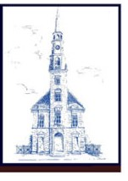We have received a gift from the Delaplaine Foundation for $25,000, and in addition, paid contributions $43,500 plus promises for additional $27,300. We have also received a challenge pledge of $25,000 from a long-time friend of ERUCC. If we are able to match the challenge pledge of $25,000 with $25,000 in new gifts, then we will be within $5,000 of our goal of $150,000 for the Trinity Steeple Campaign. We want to reach this goal by the end of September. Become a part of history and preserve Frederick’s oldest steeple and town clock!

Donations should be made payable to ERUCC and include Trinity Steeple in the memo line. Alternately, donations can be made online at <https://erucc.org/give-to-erucc>, indicating “Steeple” on the memo line.

Plan also to join congregation and community members at a reception celebrating the Trinity

Chapel steeple and town clock on May 25 from 5:00 to 7:00 pm. Details will follow in the coming days, so mark your calendar to attend!

**A Spring Picnic for LGBTQ+ Families**

**Saturday, May 14 Urbana District Park – Pavilion 1**  **11:00 am – 2:00 pm**

Hosted by the committee working to establish a Frederick PFLAG Chapter and supported in part by The Frederick Center, come enjoy community and a picnic in the park. Drinks provided, bring your own food.

**Opportunities to Use Your Gifts at ERUCC**

Prayerfully consider how your talents, skills, and passions can be a blessing to ERUCC’s mission and ministry. Where is God calling you to use your gifts at ERUCC? Your willingness to share your gifts and time will make ERUCC a stronger and more faithful church.

Members of our Stewardship Committee: Susan Kulp, Tyler L. York, David Howard, Julie Clark, Peter Brehm, Randi Wallace, and Stephanie Fisher are always happy to talk about how you are being called to use your gifts at ERUCC.

While many opportunities exist or await your spark of initiation, below are some ongoing areas of ministry for you to consider supporting:

**FELLOWSHIP**

Consider helping with Fellowship! It’s a great way to celebrate a birthday, anniversary, births, or baptisms with your church family. We all want to celebrate your joy. Helping with fellowship can be as easy as helping set up before worship, helping to serve during Fellowship after service, or bringing a special treat to share.

Contact Laura Rhoderick or Starr Schaeberle, or sign up to share your gifts of hospitality at **bit.ly/ERUCC_fellowship**.

**AUDIO VISUAL TEAM**

The AV Team is now displaying hymn lyrics and scriptures on screen during the Live Stream. To provide this service, we need to an additional person on the team each Sunday. We are asking for volunteers to assist with changing the slides as the hymn or scripture progresses. No technical skills are required. If you are interested in volunteering or have questions, please contact Jeff Schaeberle, [jeff@erucc.org](mailto:jeff@erucc.org) or 301.639.6197.

**KITCHEN TEAM**

We need to form a Kitchen Team to help maintain our commercial kitchen license by caring for the beautiful space we created with the building project. The Kitchen Team is responsible for overseeing the kitchen equipment, storage, and supplies. If you feel called to lead this ministry or want to help with it, please speak with Peter Brehm or Pastor Daniel.

**EVENT HOSPITALITY AND SUPPORT**

Please consider giving your time as we extend ERUCC’s hospitality to the community of people using our spaces for their milestone life events, business meetings, and community gatherings. In supporting at these events, you are helping to fulfill our mission to do good work in Frederick and beyond. Many opportunities to serve in this ministry may only involve a few hours of your time and are often very fulfilling to support.

To help with upcoming events, contact Pastor Daniel or the church office, 301.662.2762, events@erucc.org, or sign up on the bulletin board or online: **bit.ly/ERUCC_events_help**.

We have many events throughout May and June and we need your help!

**A NOTE OF GRATITUDE**

Thank you for being so gracious by hosting

The Stages of Trauma and Recovery (STAR) Model event.

Everyone was so friendly and helpful.

The attendees complimented how comfortable they were in the space

while practicing trauma-responsive

movement techniques.

Again, thank you for everything!

*We are especially grateful to Karen Justice, Susan Kulp, and Pastor Daniel for extending our hospitality for this event on April 22.*

**