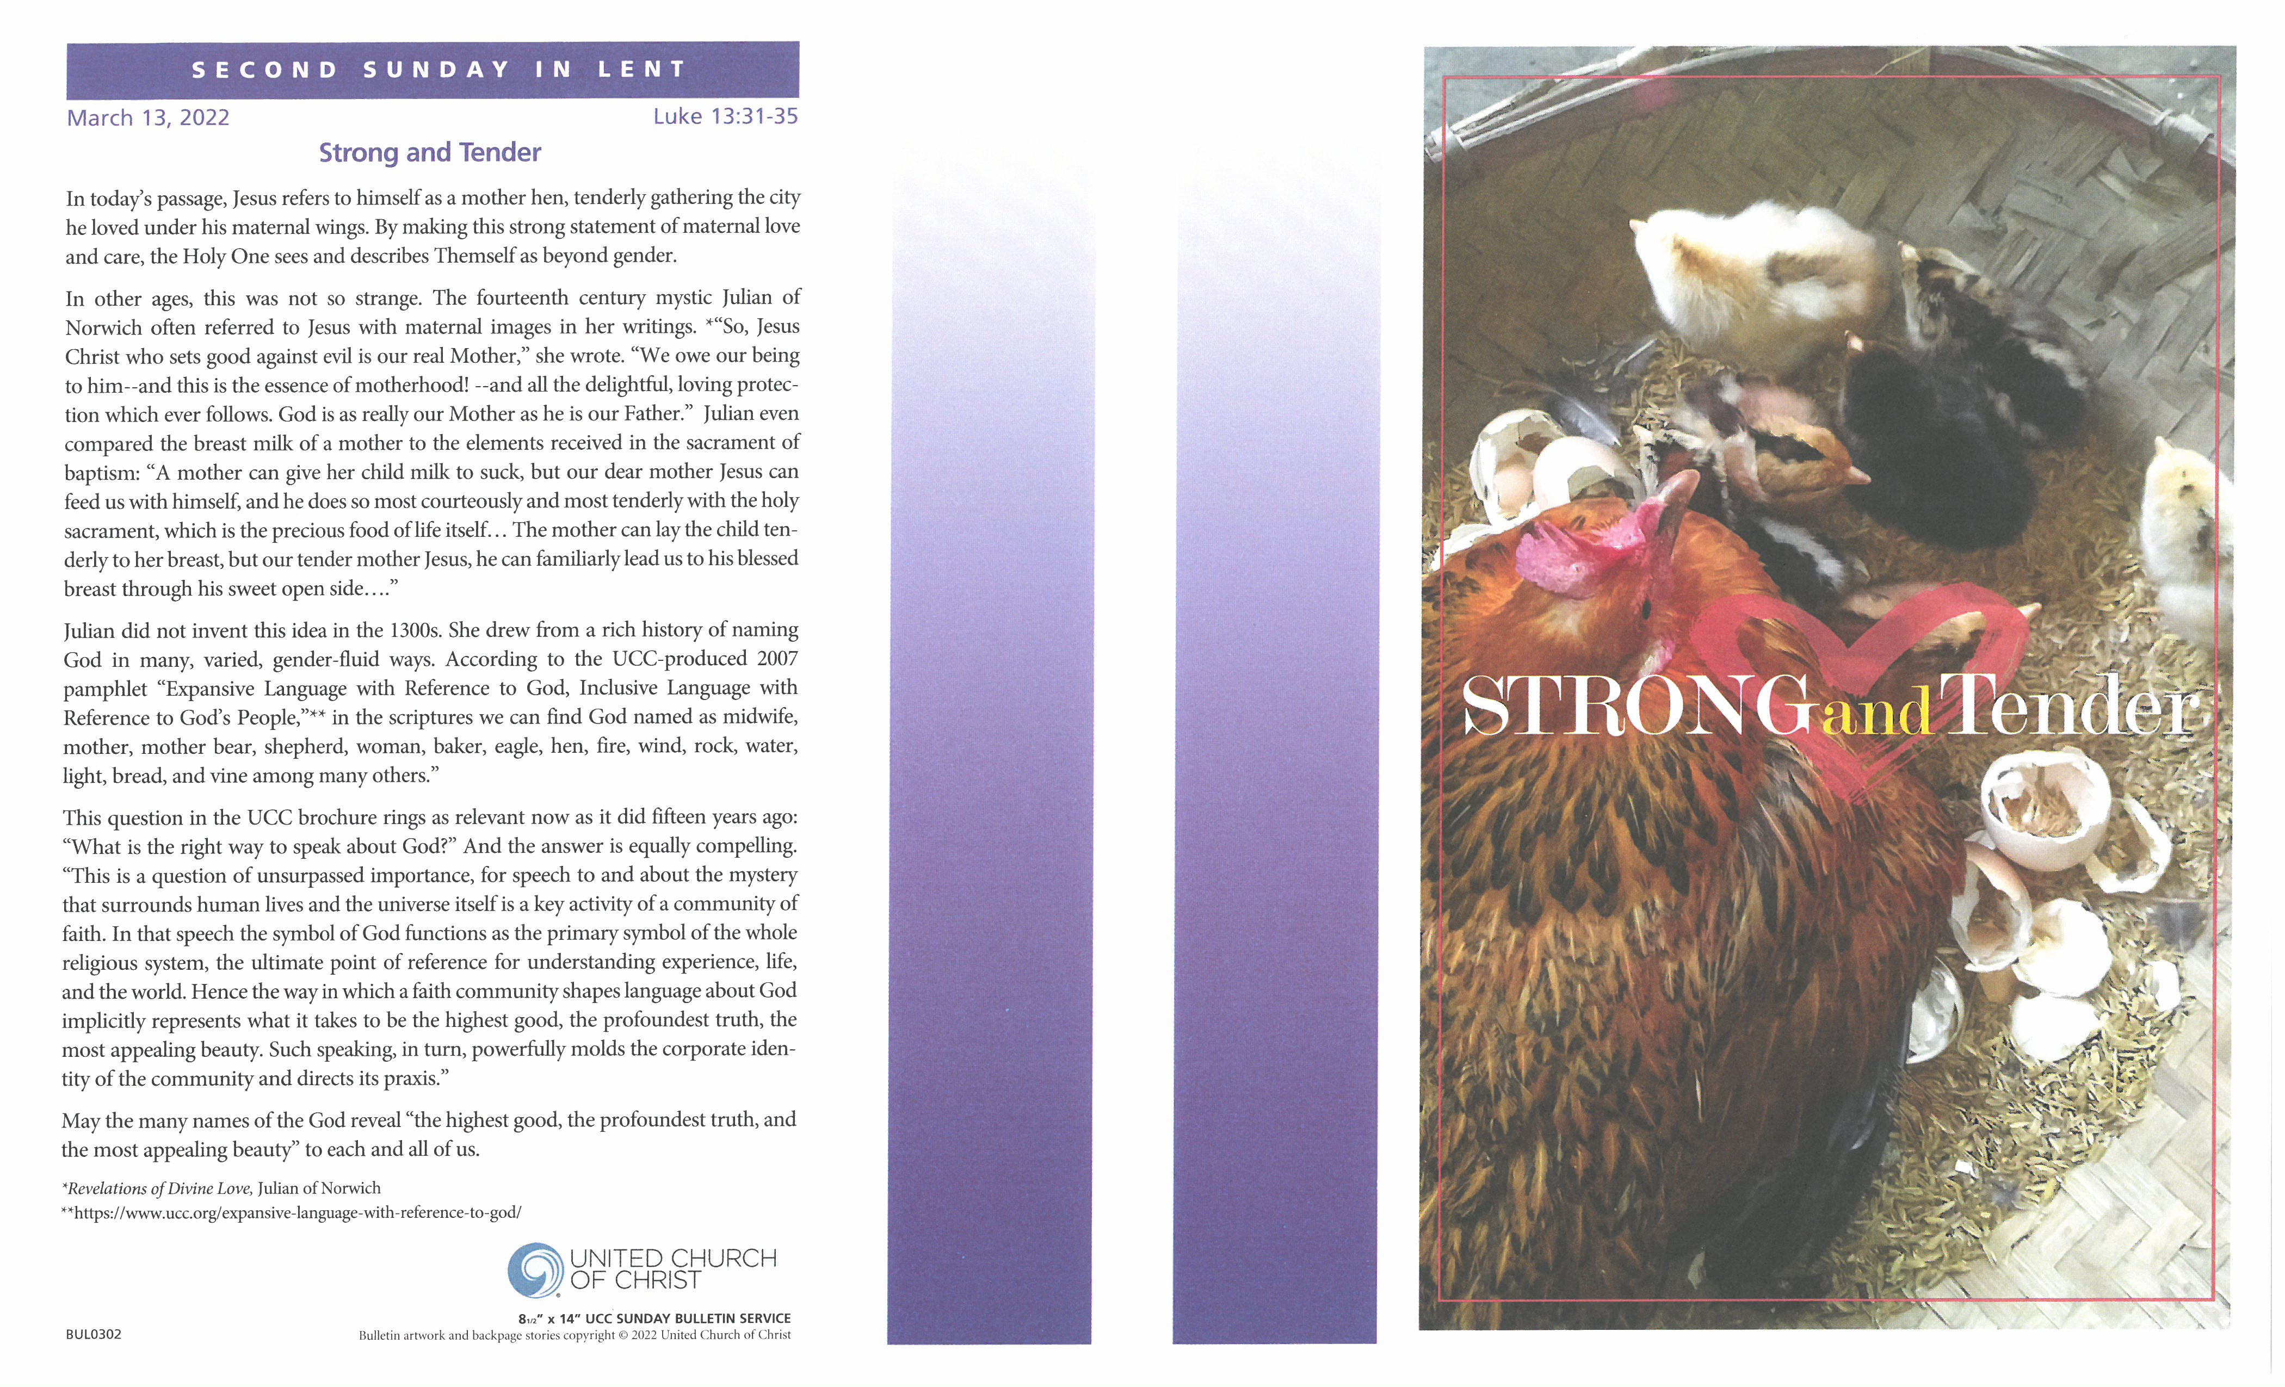
Thank you for worshiping with us this morning. We extend a special welcome to our guests.


F
or Children: We have trained nursery staff (paid nursery attendant as well as adult volunteers) for ages 0-4. The nursery is located on the first floor outside of the Community Room. (Accessible by the stairs from the Church Street Entrance or via the elevator). Children ages 5 and above are invited to stay and worship with their families. Children’s programs, books, and crayons are located in the rear of the sanctuary near the welcome table.
H
ymn selections can be found in the black hymnals in the pew racks or printed in the bulletin. If you are visiting and did not stop at the welcome desk in the downstairs lobby please stop by after the service they would love to meet you or, please feel free to reach out to someone sitting near you and ask them questions about the service or church. Many of our visitors ask us about the time of offering. This is a time in our service when we respond to God’s gifts of love by offering the gifts of our lives. For many of us, this is when we make a financial gift towards the ministries and programs of our church. We also use this time to ask God how we might use the gifts of our hands and hearts in sharing God’s love. If you are visiting, there is no obligation to give a financial gift. We are just glad you are worshiping with us. At this time, we are taking offering at the end of the service. Plates for offering will be placed at the doors as you exit the sanctuary. Thank you.

We ask that you please silence your cell phones during our worship service. We also ask that you refrain from applause after our choirs sing and allow the music to resonate in the quiet of the sanctuary and in your hearts. Our musicians are playing and singing for the glory of God. They know you appreciate their efforts and their gift.

Rest rooms (equipped with changing stations) are located on the first floor of the church building and outside the Community Room and the Nursery.
T
here is much information about the church in this bulletin and our website: www.erucc.org.

Donate online by scanning this code:
or download the GivePlus Church application and
make your donation via the app. Thank you.


Ministers - All the People of Evangelical Reformed Church
Rev. Dr. Barbara Kershner Daniel, Senior Pastor (bkdaniel@erucc.org)
Rev. Fred Wenner, Pastor Emeritus (faw500@msn.com)
Kim Sexton, Associate for Children’s Ministry (ksexton@erucc.org)
Alison E. Shafer, Music Director ● Tricia Coffey, Head Chimer & Children & Youth Choir Director
Sherry Murray, Nursery ● Jaci Clayton, Facilities Mgr.
Tyler L. York, Office Administrator (erucc@erucc.org) ● Jenna Duranko, Social Media Coordinator
15 West Church Street, Frederick, MD 21701  301-662-2762  www.erucc.org

EVANGELICAL REFORMED CHURCH

United Church of Christ

- An Open and Affirming Congregation -

March 13, 2022 Second Sunday in Lent 10:30 am

*All who are able may stand

Filled to the Brim: Under God’s Wing

Chimes Concert at 10:00 am from Trinity Chapel’s steeple

Greetings and Announcements
Honoring of our Scouts and Scouting Leaders

Prelude

Threshold Moment Come Rain or Shine
“I will keep on.”
That’s what I heard him say.
I will keep on
driving out demons
and healing people,
speaking the truth
and loving endlessly,
searching for the lost sheep
and crying for the brokenhearted,
feeding the hungry
and welcoming the outcast.
“I will keep on.”
That’s what he said, right
after he said my name, right
after he called me beloved, right
after he welcomed me home
and saved me a seat.
And I knew,
there was no stopping him.
I was under his wing.
Come rain or come shine,
today and tomorrow,
this love keeps on.

A Time of Silence

*Call to Worship
If God is a hen,
we are under God’s wing.
If God is a table,
we each have a seat.
If God is a house,
we are safe from the storm.
If God is a party,
we’re invited to dance.
If God is a melody,
our names are the lyrics.
If this is God’s house,
then all are welcomed. All are loved. All belong.
Let us worship Holy God.

*Opening Prayer
Holy God,
this life of ours is full to the brim.
Our days are overflowing with emails and to-do lists,
schedules and notifications,
assignments and deadlines.
We wake up feeling behind,
we go to sleep worrying about tomorrow,
and we know—there has to be more than this.
So we pray:
bend down and show us the way.
Leave breadcrumbs in the street.
Point us toward awe and wonder.
Guide us to intimacy and trust.
Gift us with laughter that will make us cry
and hope that will make us feel alive.
We want a new kind of full to the brim.
Show us the way.
We are listening for your cues.
Gratefully we pray, amen.

*Opening Hymn There Are Some Things I May Not Know #405

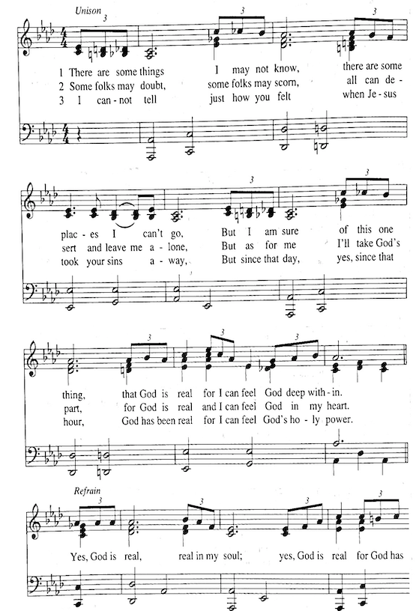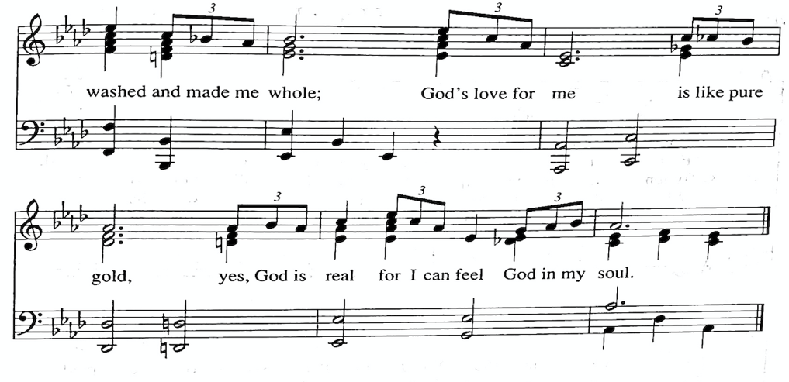
*Call to Confession
Family of faith, we come to confession not to wallow in our own guilt.
Instead, we come to confession because we know that change starts with being honest. So in a desire to grow and change, let us pray to a God who loves us like a mother hen. Let us confess our sins together. . .

*Prayer of Confession
When the Pharisees tried to stop Jesus, Jesus said,
“I will keep on.”
I will keep on healing.
I will keep on teaching.
I will keep on preaching.
I will keep on flipping the tables of injustice.
I will keep on treating every person like a child of God.
I will keep on believing that this world can change.
I will keep on
and keep on
and keep on until God’s promised day.
Forgive us, God, for the times when we stop. Amen.

*Assurance of Pardon
Family of faith, because Jesus’ love just keeps going, we can trust that that love and grace exists for us. So rest in this good news:
No matter what we do wrong or what we leave undone, we are under God’s wing. Amen!

Thought For the Day

The Lord’s Prayer
Our Father, who art in heaven
hallowed be thy name.
Thy kingdom come. Thy will be done
on earth as it is in heaven. Give us this day our daily bread.
And forgive us our debts, as we forgive our debtors.
And lead us not into temptation, but deliver us from evil.
For thine is the kingdom, and the power, and the glory, for ever. Amen.

*Hymn Glorious Is Your Name, O Jesus #53

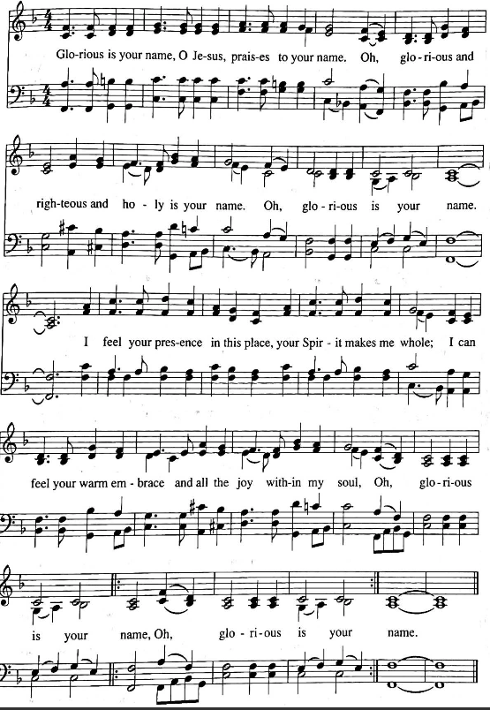

The Scripture
Psalm 27 OT page 180
Luke 13: 31–35 NT page 61
Reader: The Word of God for the people of God.
All: Thanks be to God.

Sermon
Morning Prayers

Offering of Tithes, Gifts and Lives to Christ’s Service

Offertory The Lord Is My Light --A. Crouch Spirit
*Prayer of Dedication
Ever Present, Life Giving God, may these gifts be used to pass on your peace, justice, and healing. Amen.

*Closing Hymn We Are Marching in the Light of God #526
1. Marching 2. Living 3.Loving

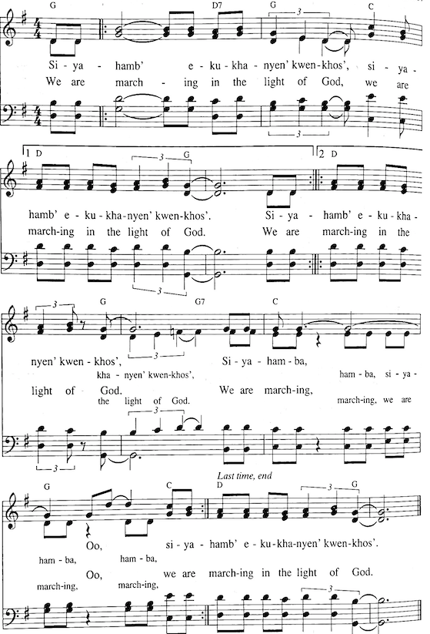

*Blessing
As you leave this place,
may you be awestruck by the beauty of this world.
May you laugh, and may it be contagious.
May you overflow with love for those around you.
May you be effusive with hope and quick to point out joy.
And in all of your living, and breathing, and being,
may you find yourself full to the brim with God’s Holy Spirit,
and may it change your life.
In the name of the Lover, the Beloved, and Love itself—
go in peace, full to the brim. Amen.

An Old Irish Blessing --T. Jennings Spirit

Postlude (please be seated)

Today’s liturgy was written by: rev. sarah speed | sanctifiedart.org | The prayer of dedication is from UC Worship Ways for March 6, 2022 written by the Rev. Michelle L. Torigian.

Girl Scouts
The following are active in Girl Scouts: Zoe Bowen, Laurel Nguyen-Powell, Kali Chappell, Alex Cumber, Paige Coffey, Peyton Bowen, Emma Baker, and Katie Zander

Adults active in Girl Scouts: Kim Sexton, Catie Schaeberle, Julie Chappell, Barb Barry, Tricia Coffey, Thi Nguyen and Evelyn and Tom Frazier.

Adults in our congregation who have earned Girl Scouting’s highest award, the Gold Bar, First Class or Gold Star: Eleanor Fisher, Kim Jahoda, Barbara Kershner Daniel, RaeAnn Butler, Catie and Kim Sexton

Boys Scouts
The following are active in Boy scouting: Austin Bowen, Lucas Nguyen-Powell, and Eli Baker

Adults active in scouting: Marc Kline and Jennifer Powell
Members of our congregation who are Eagle Scouts: Chris Spear, Mike McGreevy, Bud Rossig, Allen Maples, Randy Gigante, Mark Daniel, Chris Daniel, Tyler Schaeberle, Alex Schaeberle, Sean Sexton, Ethan Kline and Aiden Baldree

The flowers on the altar this morning are given by the Maples/Rhoderick family in loving memory of Sam Maples.

The yellow rose bud is presented by Jim and Angela Britain in honor of their second cousin, 1st Lt. Matthew James Reed, 82nd Airborne, Fort Bragg, NC.

Attendance Last Sunday: 13 at 8:30 am, 147 at 10:30 am, and 91 online.


Watch worship live every Sunday at 10:30
https://sundaystreams.com/go/ERUCC


Want to listen to the sermon again?
Visit our YouTube channel: bit.ly/erucc_youtube

Today: March 13, 2022 March 20, 2022
Liturgist: Austin Byrd Glenn Wallace
Poetry Reader: Nancy Jones Dan Smith
Deacons: Chuck Baldree, Matt Pomeroy Joe Adkins, Matt Davis
Elder: Peter Brehm Tyler L. York
Greeters: Jo Ann Fritz, Cathie Duncan Tom and Rachel Ford, Sue Pinner Linda Coyle
Welcome: Jeanellen Kallevang Holly Davis
Sound: Kelly Esslinger, Jeff Baker Rodney Martin, Jack Day
Tadd Clarkson Larry Martin
Fellowship: Starr Schaeberle Julie Clark
Chimers: Saturday: Dick Williams Suzanne Morris
Sunday: Kelly Esslinger Tricia Coffey

ANNOUNCEMENTS
Worship Next Week: Third Sunday in Lent: You Are Worthy
Focal Scriptures: Luke 13:1-9 | Isaiah 55:1-9
Like the fig tree, you are worthy. You’re not a lost cause. You’re not a waste of resources. You deserve audacious hope. You deserve to be nurtured. Your fruit will come. Like the gardener, you are invited to see others with audacious hope and budding potential. The lesson of the fig tree invites us to unpack the source of our worth in a system and society that often measures worthiness by commerce, production, output, success, status, achievement, ethnicity, and/or gender identity. We might ask, “Can the fig tree have worth even if it never produces any figs?” What does that mean for us if the answer is “yes”? Patience, nurture, asset-based thinking, and audacious hope are counter-cultural practices needed for an expansive life.

The Senior Choir will be singing.
Hospital and Prayer List – Your pastor wants to be available when members of ERUCC are in the hospital. Please let us know so that we can visit with you and your family and provide support. We always ask permission before adding a name to be included in the prayer list or in the verbal announcements on a Sunday morning. There are many for whom we pray and visit whose names are not listed in the bulletin by their request.

Prayer List - Please remember the following people in your prayers: Michael Rebo (brother-in-law of Jack Day), Robin Fenwick (mother of Owen York), Jerry Cassell (brother of Ave Barr), Katharine Alley, Barbara Lee Crutchley (sister of Milt Crutchley), Marcy Channell (daughter of JoAnn Fritz), Mack Johnson, David Howard, Paige Coffey, Al Peden, Jane Doll, Michael Rhoads (son of Barbara Rhoads), Westin (great nephew of Sandy Gray & Danielle Carbone, Peggy Githerman, Jeannette Johnson, Emogene Wyand, Fran Wenner, Neremiah Castillo (niece of Andrew Beadle) Bonnie Devilbiss, Maria Csiba (mother of Tamara Tamas), Betsy Fisher, James “Jimmy” Sutphin (friend of Dan Smith), The McCarty family, Nikki Keller, Tina Prescott (daughter in law of Barbara and Bill Prescott), Mary Remsberg, Heleen (sister of Karin Mens), Kathy Blue Shores (friend of Jean Fish and Barb Biser), Gretchen Manuel (niece of Audrey Rayfield), Ann and Cal Theiss (parents of Katharine Alley), Debra Reedy (friend of Jean Fish and Barb Biser).

FELLOWSHIP
Please join us for refreshments and fellowship in the Community Room following the service.

Sunday Education Opportunities for Adults

BIBLE STUDY CLASS Online 9:00 – 10:20 am
“The Book that Breathes New Life” with Reverends John & Rebecca Shillingburg.
To join via Zoom: bit.ly/3GEIvhJ Meeting ID: 893 8670 5888 Passcode: 327128

The Online Bible Study began a six-week study of the Prologue in Genesis (chapters 1-11) on March 6. In these texts, a small, unimportant wandering people of the Ancient Near East made an astounding claim: their God, who had no visible image to be worshipped, created the entire world ... simply by speaking. Join us for a look at how that claim has shaped us today.

LET’S TALK 9:30 – 10:15 am
Returns today for Creation Justice Month! Let’s talk about ways we can care for the earth through personal choices in how we eat, shop, dispose of waste, and care for our landscapes. Join us in exploring ways to live more sustainably.

Today’s Topic: Reuse Sunday. Reduce waste, save money and create a more sustainable lifestyle by sharing. Bring your books, puzzles, clothes and other good stuff to swap. Share your ideas for transforming old things into new. Get information on recycling all kinds of things. –Terry Logee, Nancy Jones and Linda Coyle

On March 20: Composting ABCs. Find out why ERUCC is composting and what it has to do with creation justice. We’ll share how to get started at home as well as how to sign up for a composting service. If you already compost, come share your experience and technique.
–Terry Logee, Linda Coyle, David Howard and Cliff Barr
This Week at ERUCC
GREEN TEAM – SHARING SUNDAY Sunday, March 13
Do you have books, puzzles, games and clothes that you no longer use but are still in good condition? Bring them in to swap, trade or give away during Fellowship in the Community Room after the service! You can drop items off during Let’s Talk at 9:30 am, when we will share ways to reuse and recycle.
SPIRITUAL WALK Sunday, March 13 2:00 – 3:30 pm
2250 Bear Den Rd (condo parking lot)
Join us for a walk in Wormans Mill. Marj Berkheimer helped us plan a beautiful route along Tuscarora Creek and through wetlands and woods. Many birds and other wild creatures create a joyful spiritual atmosphere here. In addition, we will walk past the ruins of the Mill Pond House. Jennie Russell, our ERUCC historian will come along to fill us in on the story behind the ruins. The trail is paved and accessible.
SOLAR ENERGY AT ERUCC Sunday, March 13 7:00 pm
As we discern our plans for replacing the roof of the main sanctuary in 2023, we are consider this option of adding solar panels as well. Solar panels would be a significant action we could take as a Creation Justice church to demonstrate our covenant to be good stewards of God’s creation and our resources. There is much to consider and your input is invaluable. Please join the Property Committee for more information and a conversation about the possibilities of harnessing energy from the sun.
To join via Zoom: bit.ly/eruccproperty Meeting ID: 842 2471 9533 Passcode: 306203
Upcoming at ERUCC


FRANKLINTON CENTER WORK TRIP March 18 – 21
Next weekend, a group of adults and youth are going on a work trip to The Franklinton Center at Bricks, a conference, retreat, and educational facility in eastern North Carolina, which focuses on justice advocacy and leadership development.

Please support the trip by donating food! Sign up to donate at bit.ly/3pPa29R

MARCH ERUCC BOOK GROUP Contact Pam Shepp for more information
How the Word is Passed by Clint Smith March 22

Read book synopses in the March edition of the Trinity Chimes at bit.ly/MarchChimes.

CAMPAIGN TO RESTORE AN ICONIC STEEPLE
We are initiating the Campaign to Restore an Iconic Steeple. Read more about the campaign in the March edition of the Trinity Chimes at bit.ly/MarchChimes. We will have a special luncheon presentation on Sunday, March 27, after church, that will include a speaker on the project. The presentation will take place in a hybrid manner for those who cannot attend in person. A booklet describing the effort will be available during that event as well.

Please plan to join us at this March 27 event. So that we can plan for the meal, please let us know about your plans to attend by emailing an RSVP to erucc@erucc.org.

COMMUNITY VACCINE CLINICS
Wednesdays – March 16, 23, 30 Community Room 2:00 – 4:00 pm
ERUCC is collaborating with The Community Vaccine Coalition to help get more people vaccinated against COVID-19. It’s free, safe, and no ID or insurance is required. Please help share the word of these clinics.

UPCOMING SPECIAL GIVING OPPORTUNITY
On March 27, dedicated gifts to One Great Hour of Sharing (OGHS) will help fund international programs in health, education and agricultural development, emergency relief, refugee ministries, and both international and domestic disaster response. These funds are administered by Wider Church Ministries, Global Sharing of Resources.

ERUCC SCHOLARSHIPS AVAILABLE

ERUCC is fortunate to have several scholarship programs available to our members as they seek educational opportunities to develop knowledge and skill in realization of their full potential. These scholarships are gifts to church members for post-secondary undergraduate education. The awards, distributed by the Scholarship Committee, are based on the quality of the candidate's plan for use of the funds, the ability and promise of the applicant, and the need for financial assistance. The aid may continue for subsequent years after an interview with the Scholarship Committee, submission of intent to reapply, and a transcript of grades for the current year.

Scholarship applications for new and renewing applicants are available through the Church Office, erucc@erucc.org or 301-662-2762. All application materials must be submitted to the Scholarship Committee through the Church Office by the April 30 deadline.

You may direct questions to Sandra Trout, Chairman of Scholarship Committee, at troutsandra@aol.com or 301-676-6585.

Children and Youth

Youth Group
Sunday, March 27 Community Room after church
The Youth Group will bake cookies for first responders after church as their March service project, organized by Paige Coffey.

God’s Kids Club – Lego Day
Monday, March 28 Community Room 9:00 am – 2:00 pm
Bring a bag lunch, water bottle and gently used toy or book for a bingo prize. Middle or high school volunteers welcome. Please sign up by March 23: bit.ly/3LYEsAe

Weekly Education Opportunities for Adults
TUESDAY MORNING BIBLE STUDY with Pastor Daniel Zoom / Liz Coffey Room
11:00 – Noon March 8 – April 12 Lent in Plain Sight
God is often at work through the ordinary: ordinary people, ordinary objects, ordinary grace. Through the ordinary, God communicates epiphanies, salvation, revelation, and reconciliation. It is through the mundane that we hear God’s quiet voice.

In this devotion for the season of Lent, Jill J. Duffield draws readers’ attention to ten ordinary objects that Jesus would have encountered on his way to Jerusalem. In each object, readers will find meaning in the biblical account of Jesus’ final days. Each week, readers encounter a new object to consider through Scripture, prayer, and reflection.

To join via Zoom: bit.ly/3K21Hav Meeting ID: 897 6651 9688 Passcode: 357385

WEDNESDAY EVENING BIBLE STUDY with Esther Ziegler Trinity Chapel
7:00 pm

Freeing Jesus by Diana Butler Bass. The subtitle of the book is “Rediscovering Jesus as Friend, Teacher, Savior, Lord, Way and Presence” and Dr. Butler Bass presents a chapter on each of those titles and descriptors used for Jesus. Participants will be expected to read about 30 to 50 pages of the book each week but the print is fairly large and generously spaced.
March 16 Chapter 5: Way
March 23 Chapter 6: Presence

UPDATED COVID-19 PROTOCOLS
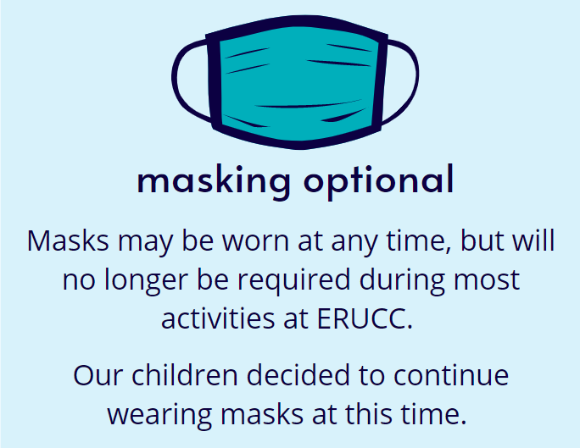
Throughout the ongoing COVID-19 pandemic, we have followed a plan guided by public health information and our shared values. In response to the most recent science-informed guidance from the Center for Disease Control and Prevention (CDC), Evangelical Reformed is taking the next steps into the New Normal. Masks may be worn at any time, but will no longer be required during most activities at ERUCC.

Adults and youth may participate in worship, fellowship, and activities without wearing a mask or physically distancing. We respect those who wish to continue wearing a mask and ask that everyone have a mask available should it become helpful in bringing comfort or protection to you or others. Our children decided to continue wearing masks at this time.

Whether you are cautious or comfortable, we pause to acknowledge and affirm the range of feelings you might have about the easing of restrictions that have supported our health and safety throughout the pandemic.

Read the full COVID-19 response update at www.erucc.org.

Lent 2022 at ERUCC
Full to the Brim
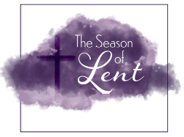
Full to the Brim is an invitation—into a radically different Lent, into a full life. It’s an invitation to be authentically who you are, to counter scarcity and injustice at every turn, to pour out even more grace wherever it is needed. Read more about Lent in the February edition of the Trinity Chimes. Lenten devotionals are available at the back of the sanctuary.

MID-WEEK LENTEN SERVICES
Wednesdays March 9 – April 13 Noon – 12:15 pm
Service of Prayer in Trinity Chapel

Lunch and Bible Study Reflection 12:15 – 1:00 pm
Theme: For the Beauty of the Earth
Each week during the season of Lent, a group gathers for prayer, followed by a simple soup and bread lunch, and some reflection.

Drawing on the beloved hymn “For the Beauty of the Earth,” each week of this 40-day Lenten devotional focuses on a different aspect of the splendor of nature, how God nurtures our spirit through creation, and how we must protect our precious home. As we walk with Jesus along shorelines, through gardens, and among trees, we learn from “the birds of the air” and “the lilies of the field.” When our Lenten journey takes us into the heart of Earth itself at Jesus’ tomb, we anticipate the resurrection with eager longing and active hope. Each five-minute devotional includes a scripture, reflection, and prayer. Every Wednesday, we will reflect on the previous week’s devotions. Please contact Pastor Daniel for a copy of the devotional book.

March 16 “For the glory of the skies”
(Skies and Air)
March 23 “For the love which from our birth, over and around us lies”
(Water, Streams, Rivers, Oceans)
March 30 “Hill and vale and tree and flower”
(Trees and plants)
April 6 “Friends on earth and friends above”
(Animals and Birds)
April 13 “Christ, our Lord, to you we raise”
(Humans Caring for the Earth)

STAY INFORMED
Read our Trinity Chimes monthly newsletter for more information about ERUCC activities, opportunities, and updates. You can find the Trinity Chimes in the back of the sanctuary and online at bit.ly/MarchChimes. If you have an announcement for the bulletin, Thursday Thoughts, or Trinity Chimes, please send to erucc@erucc.org.

This year we will be filling our chancel area with beautiful Easter lilies on Easter morning.

Plants will be ordered from the Dutch Plant Farm this year. You may take your plant home after the Easter Service.

If you would like to place an order, please fill out the information below or online at bit.ly/easlily and return payment to the church office by March 25th. The cost per plant is $13.

Donor Name: ______________________________________________________

I would like to place _____ lilies in the sanctuary for Easter morning.

If you wish your lily to be listed “in memory of,” “in honor of,” or “placed by [the donor],” please indicate which and PRINT the names below.

In memory of:
In honor of:
Placed by:

